Post Prototype Refinement
5a. Feedback
In this section of the project I will be obtaining feedback of my prototype from competent third parties. The third party I will be obtaining the feedback from is Mr Joot and 4 staff members. This will not only give me a broad range of experiences and opinions but will also give me an accurate indication of what needs to be changed in the final product. The most notable candidate being Mr Joot himself, due to him being the owner of average joot’s gym and being vocal within the pre-development stages of the project.
I will be using google forms to conduct online surveys, this enabling me to provide easy access to my surveys, as well as having the analysis tools provided by google, which will not only make the analysis of the feedback easier, but also more readable.
I will be preparing the questions in advance for consistency purposes, as well as ensuring that my questions are both relevant and effective to analyse, I will then take the feedback into consideration and make the changes required.

Question Number | Question | Justification
1 | What has your general experience been like with the prototype? | I am asking this in hope to garner a clear understanding on the individuals overall opinion of the prototype, this can give me an indication of if I’m in the correct direction.
2 | How has the prototype measured up to your expectations? | I am asking this to see if the prototype has met the expectations of the stakeholders, this is important to ensure that the stakeholders are satisfied with the product, so if it has: I am currently successful and if its not, I know what I need to do to change it.
3 | When you explored the prototype, did you become confused at any point? | I need to know if there was a circumstance within their use of the prototype where there was confusion. If I do not address any confusion, this could jeopardise the success of the final product itself. This question will be a yes/no.
4 | …If so, when? | If there was a point of confusion for a user, I would like to know what the confusion was and how it could occur. This is so I can find the issue and make the correct amendments to ensure that the final product is as excellent as possible.
5 | Do the general functions of the prototype (adding, changing, deleting, viewing records) work as intended? | This is one of the most important questions in the survey, as it is crucial that the general functions of the prototype work both as intended as well as efficiently. This to ensure successful use of the prototype as well as the success of the project itself.
6 | Do you think the prototype’s design matches its purpose? | I am asking this so I can get an idea of the user’s opinion on the design, and by making it more specific; I can see if the design is currently fit for purpose, or if there is any room for functional improvements.
7 | If there was one change you could make to the prototype, what would it be? | This is a broad question which would enable the candidate to have freedom when answering, this is so they can make any suggestion they wish for the prototype, or one which is unrelated to the questions asked previously.

I will be asking 7 questions as I believe this is a satisfactory amount to get sufficient feedback as well as to not overcrowd the survey with unnecessary questions, which could be inconvenient for the candidates to complete.
I will create the survey on google forms, and then pass the link to the survey to Mr Joot via email, who can then distribute it to 4 staff members who have used a copy of the prototype to complete.

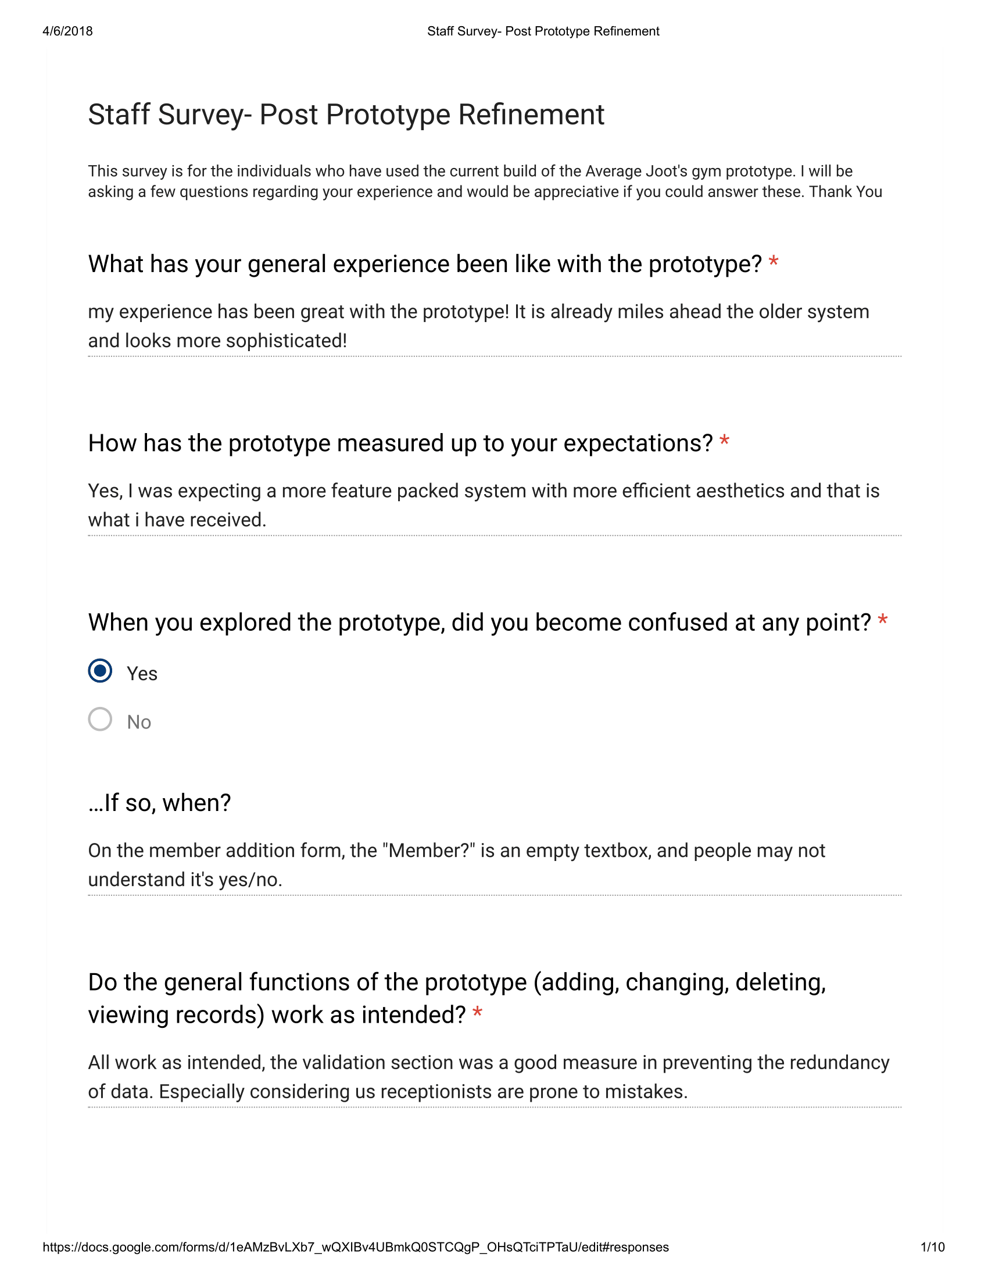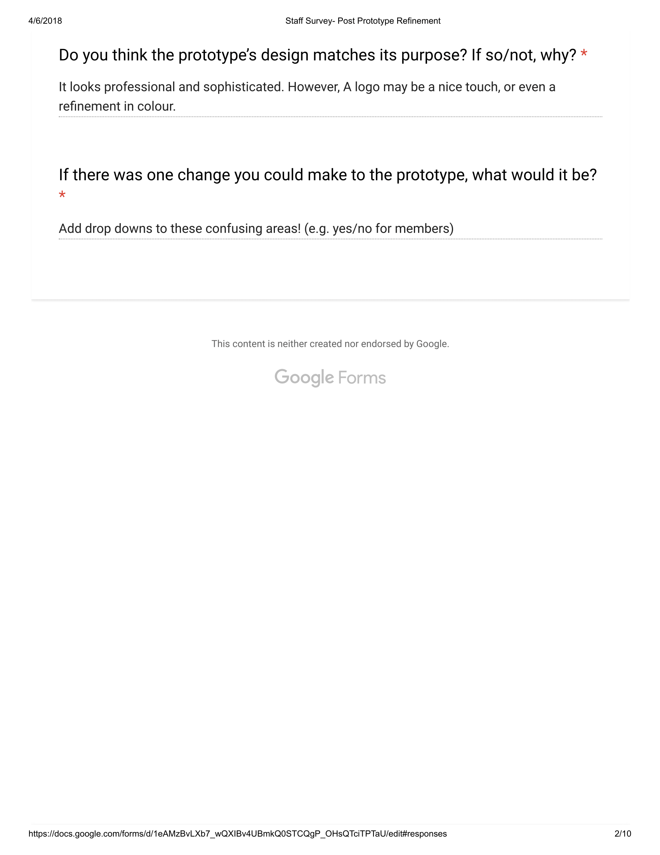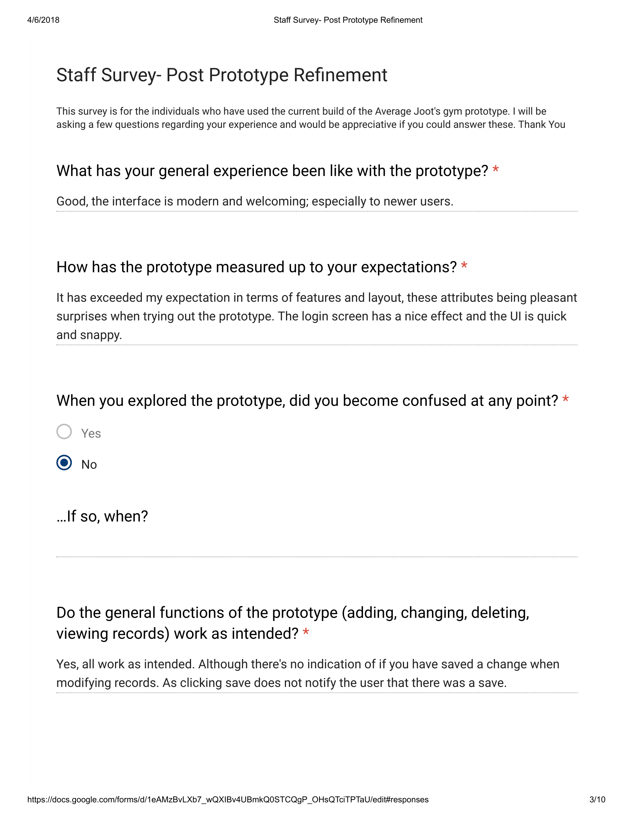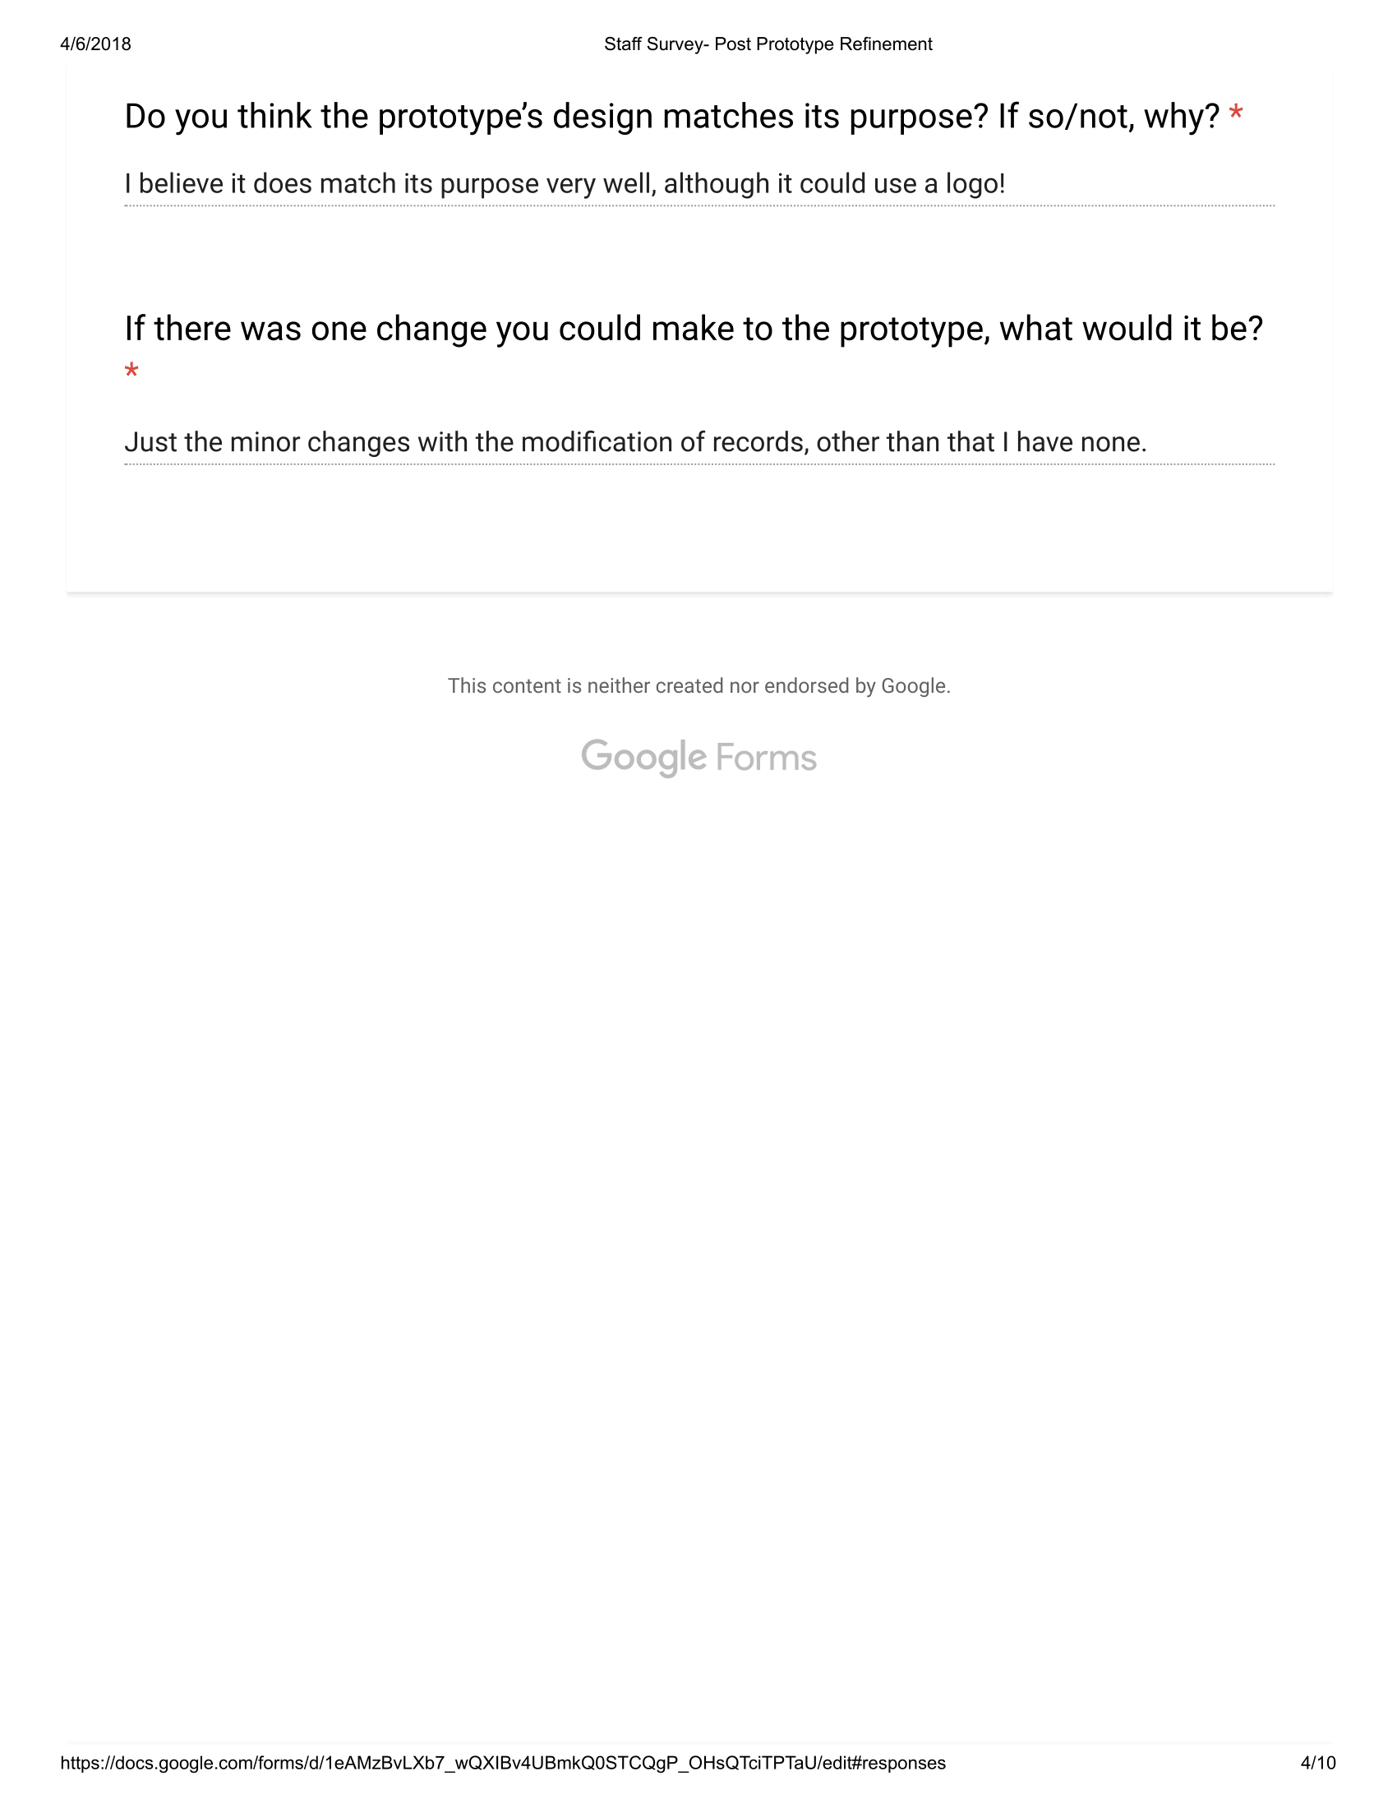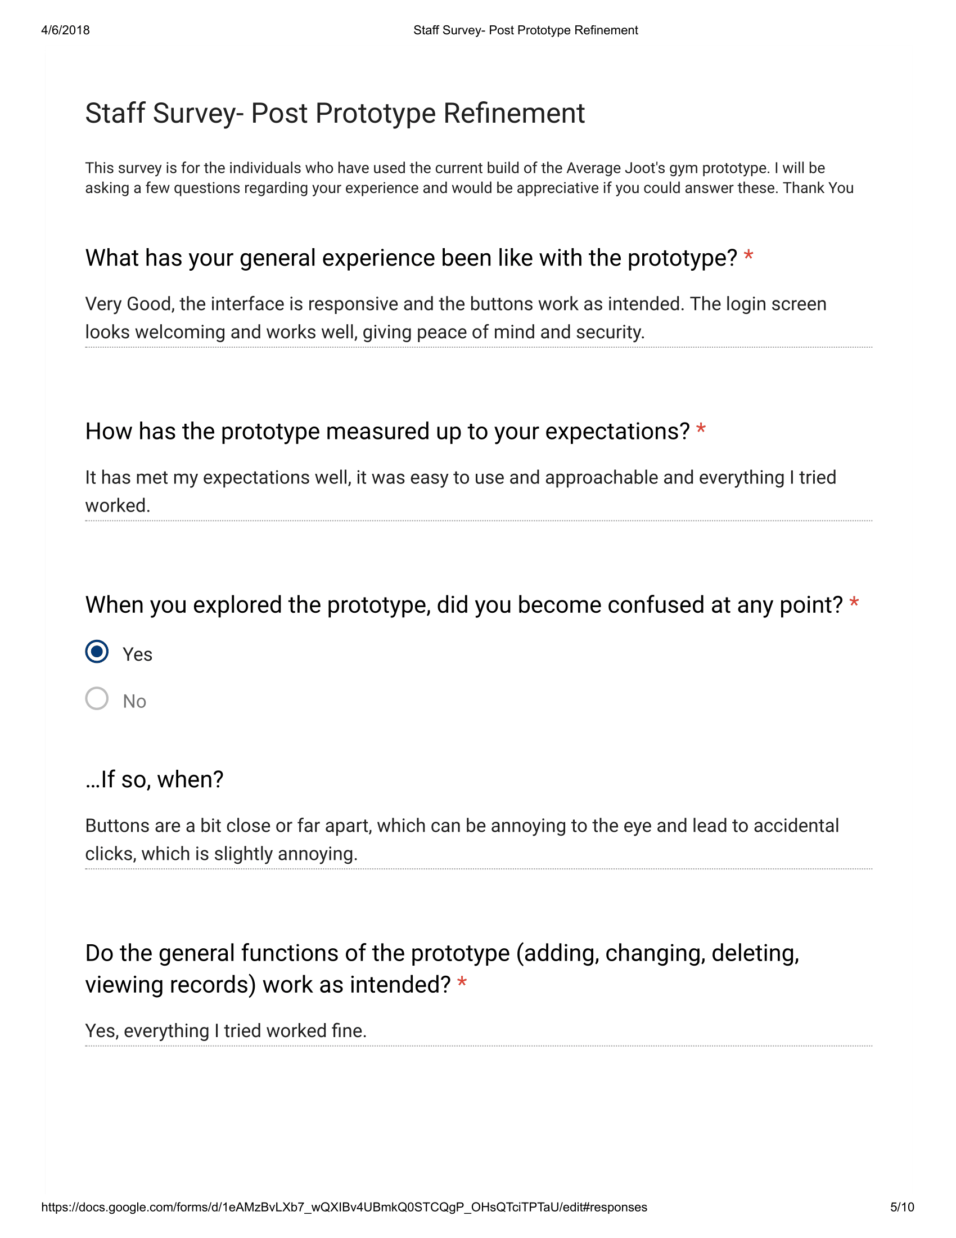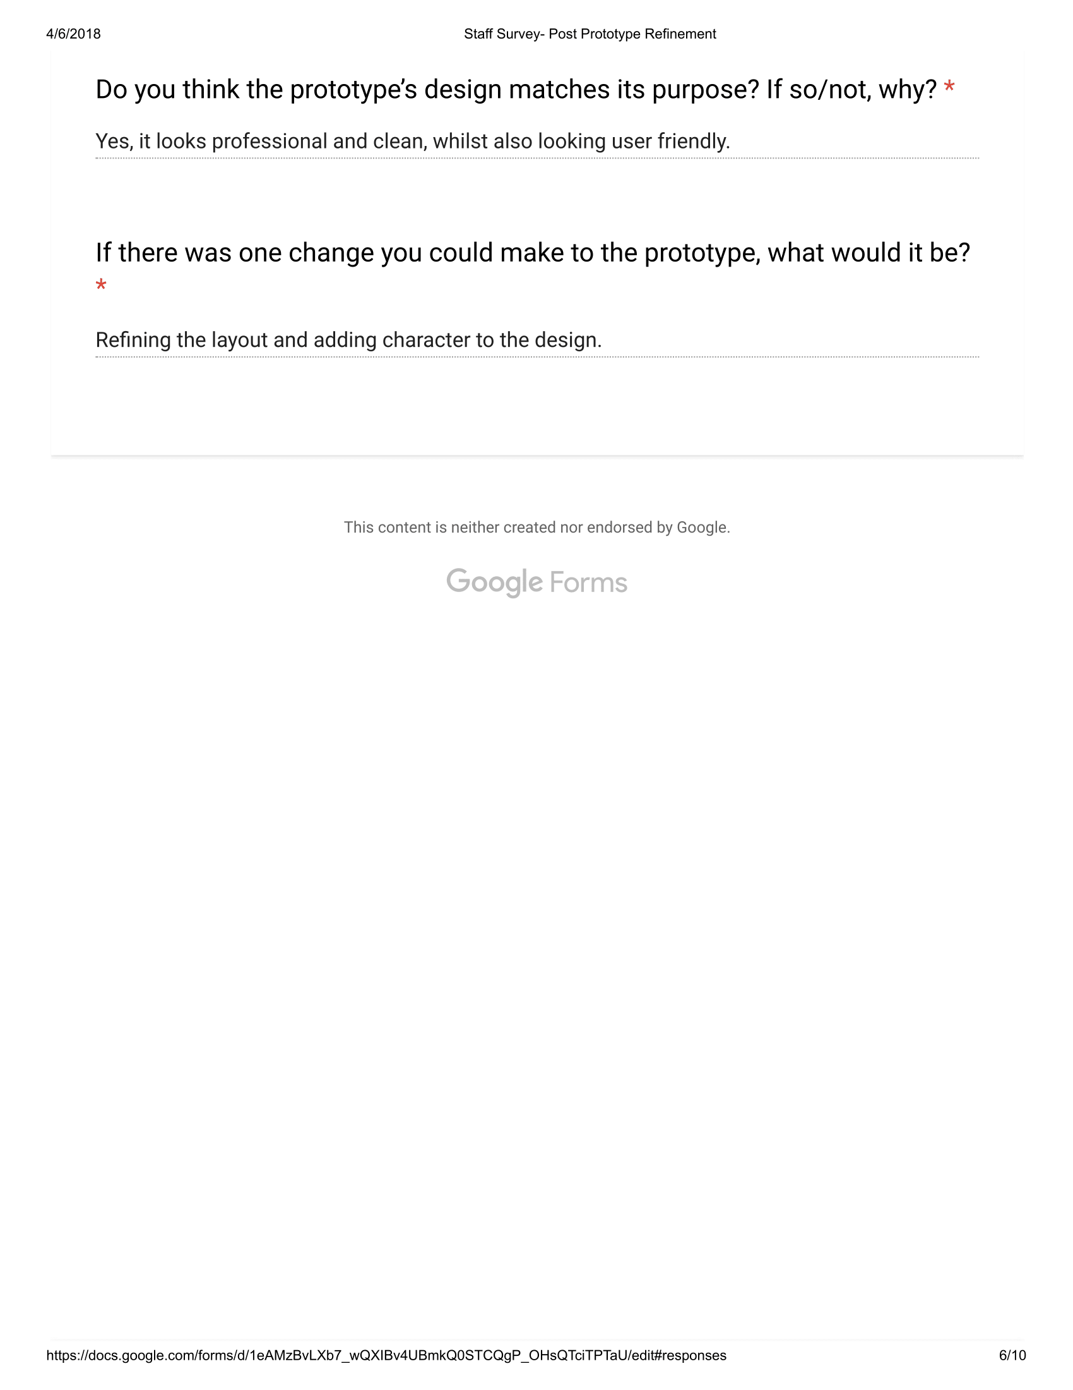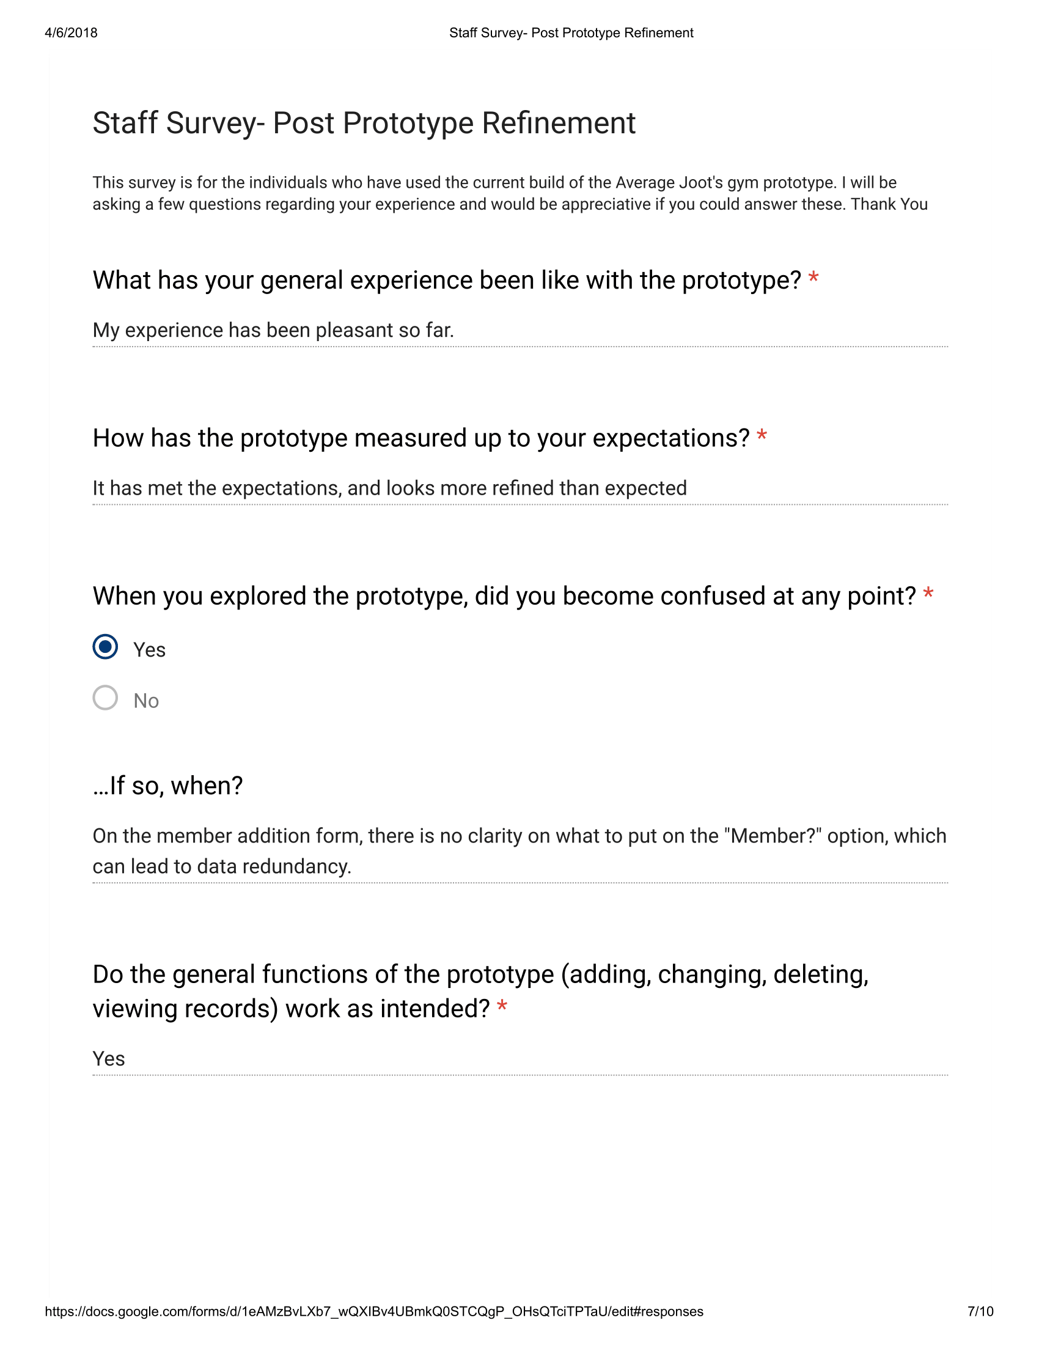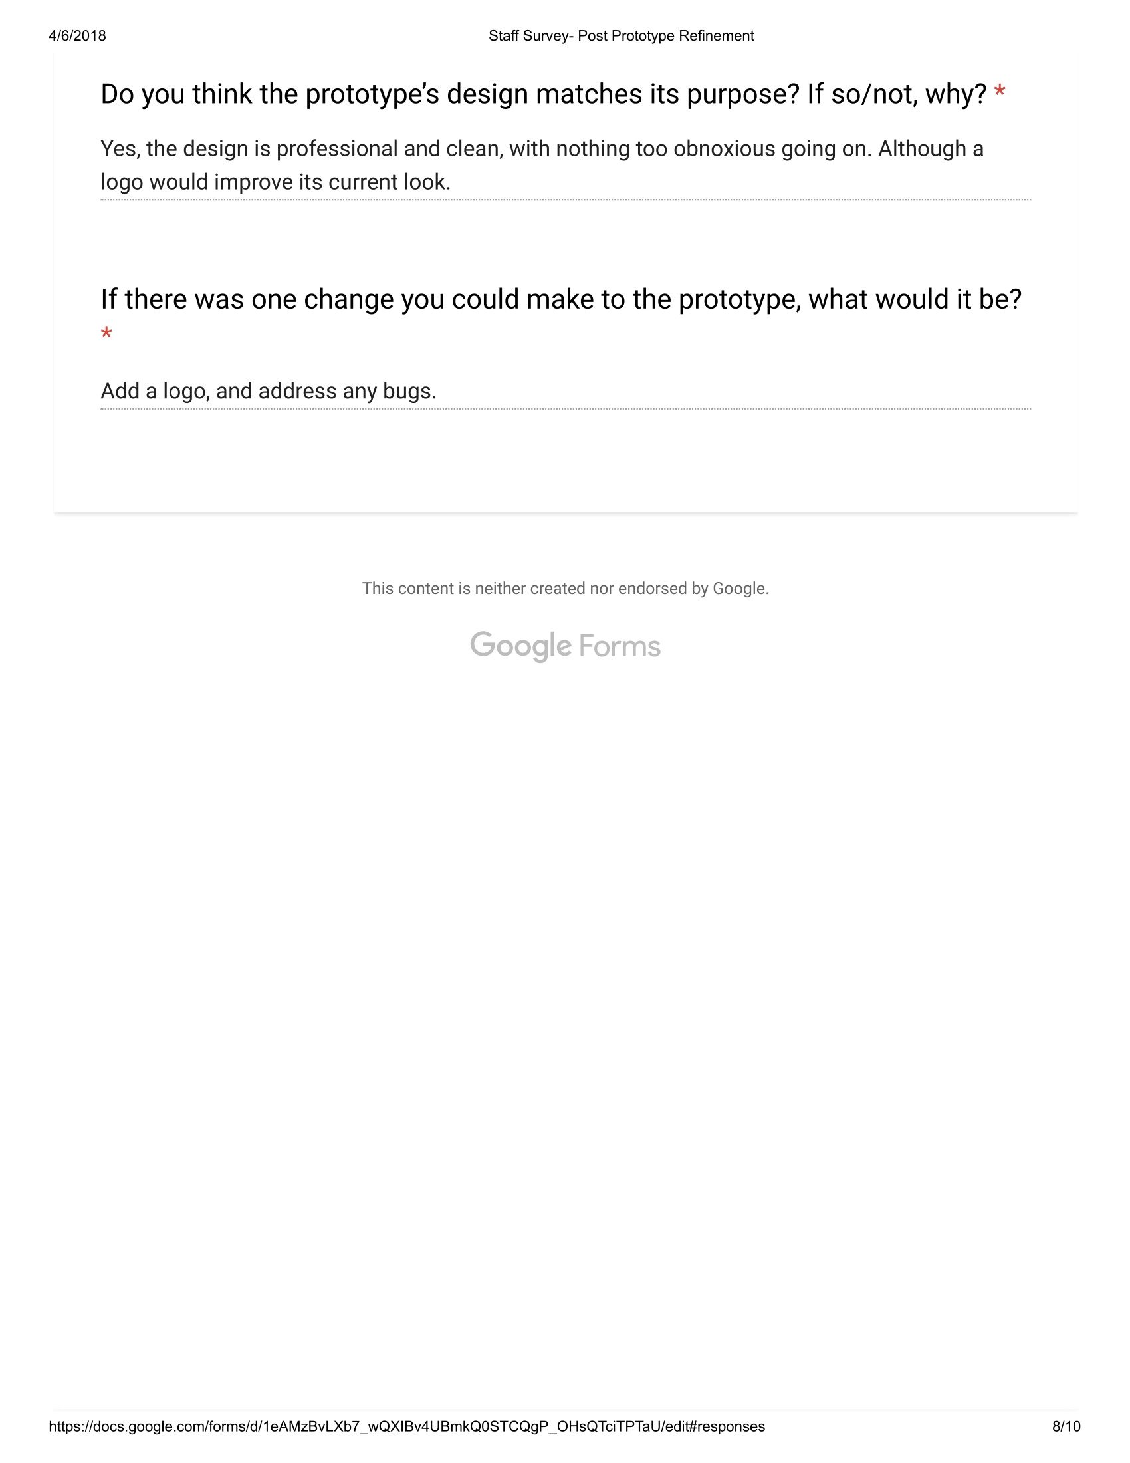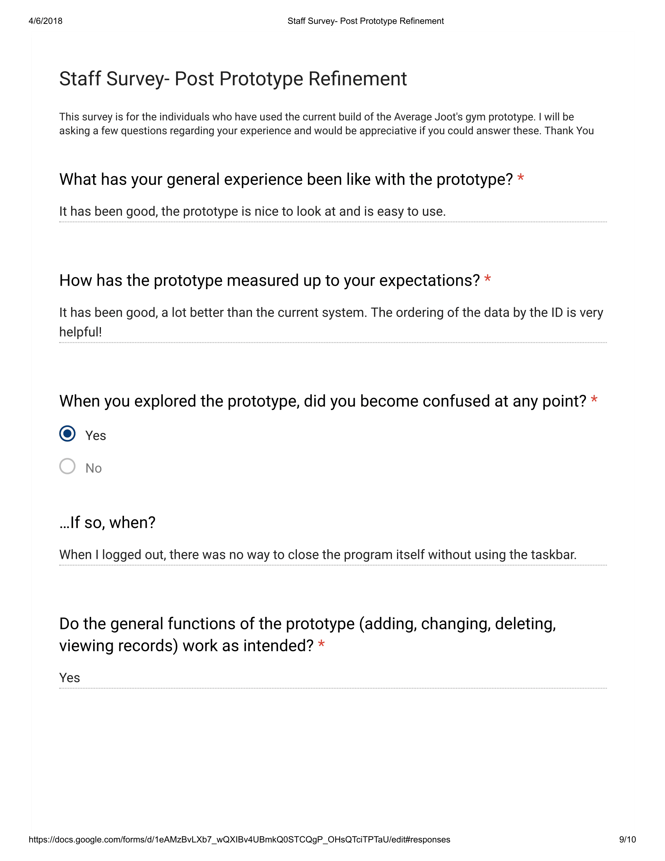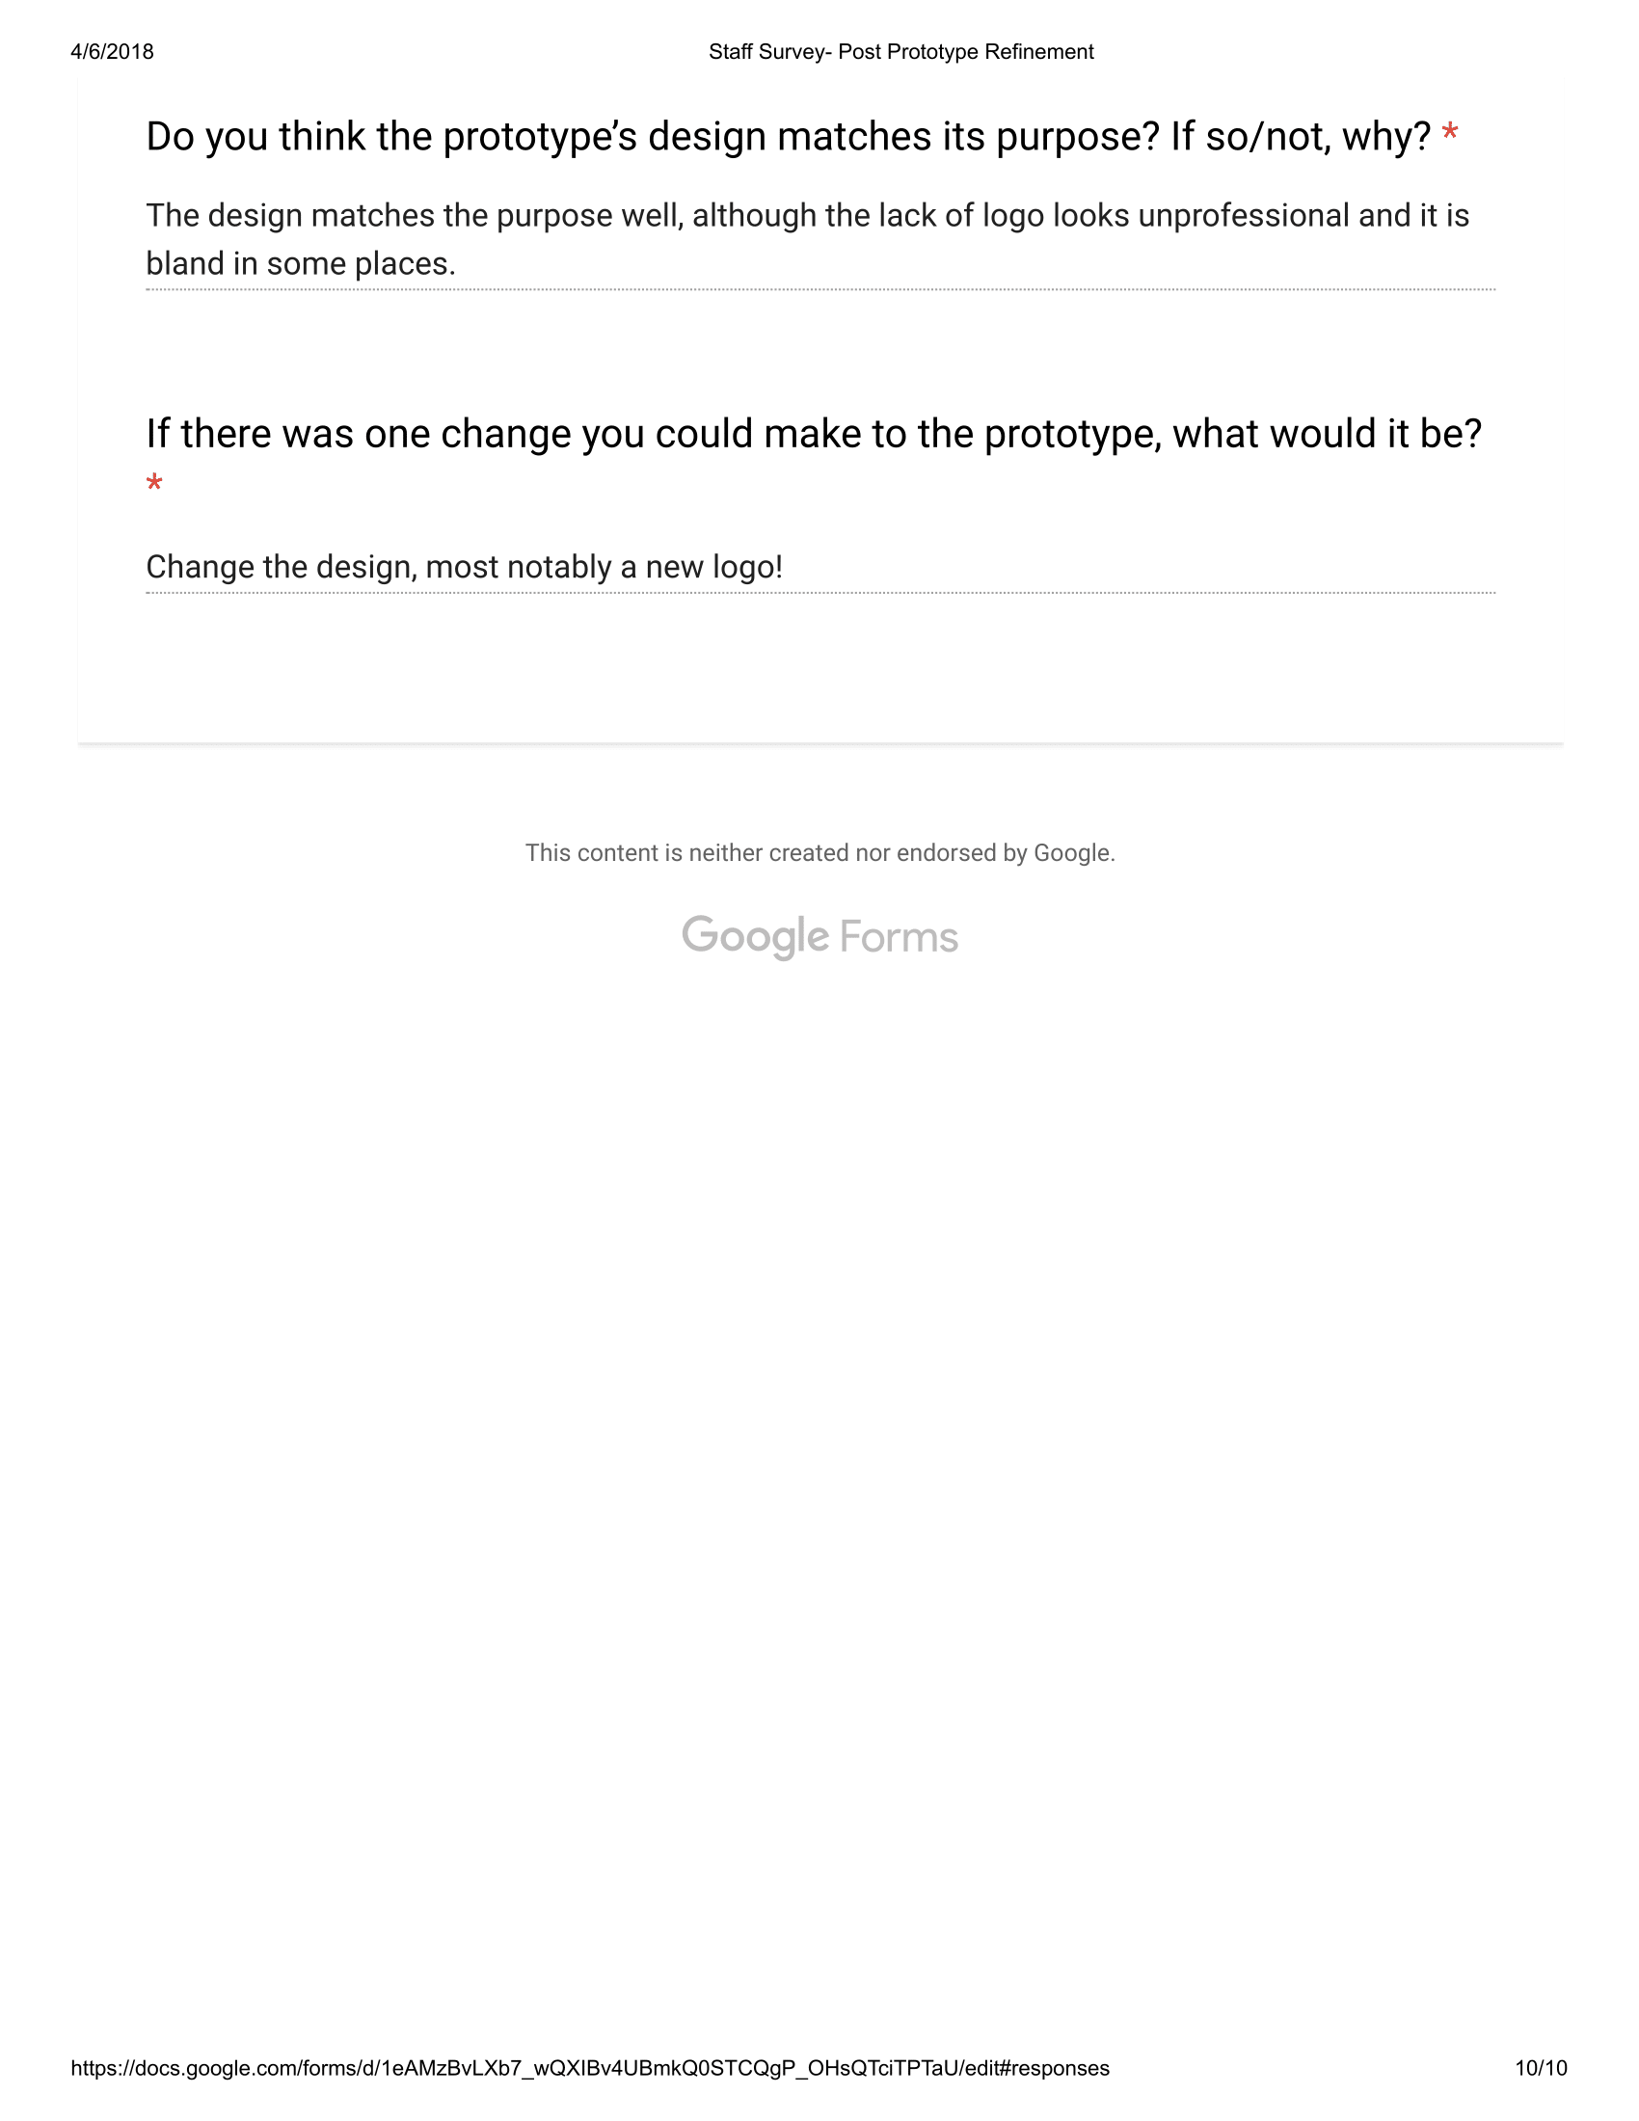

5b- Evaluation
From the feedback I’ve received, there are various improvements which can be made to my prototype. However, the general consensus of the feedback was more so cosmetic changes, rather than actual additions with functionality and features. However, there were functionality improvements, most notably to improve the convenience of use within the database; this being because there were various complaints from the users, stating that there were issues with the member addition. This being that when they wanted to click a member status, they’d have to enter yes/no manually. This being a reoccurring complaint, one user mentioning that this can lead to data redundancy if Yes/No is entered incorrectly. So the first improvement I have made is by adding a combobox with Yes/No as options when adding a member. This should address the issue with data redundancy and confusion.

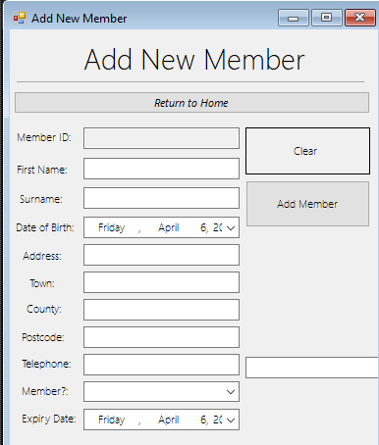
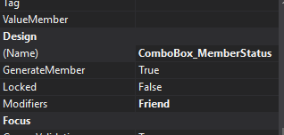
Here, I’ve added a combobox to replace the current textbox, which I have moved to the side and will delete.

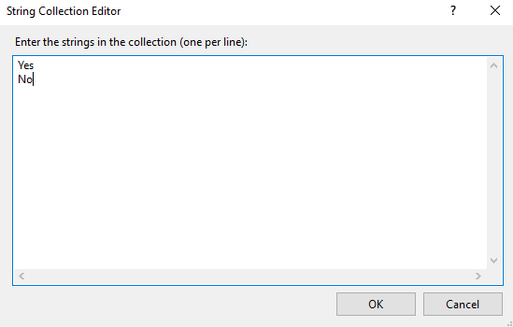
In the string collection editor for the combobox, I then added the Yes/No options for the user to select. I then removed the type check and length check for the member status, as now only presence check was required due to the options only being selectable indexes.

The Code Changes I have made are bold and magnified:

memberValidation() 'Runs the MemberValidation Sunroutine
If valid = True Then 'If the membervalidation is successful, valid will now be true. This enabling the following code to occur.
Dim newmem As New member() 'Declares a newmem, which is a variable of a new memberlist, this variable is then added to the memberList.
newmem.memberID = Textbox_MemID.Text
newmem.memberFName = Textbox_FName.Text
newmem.memberSName = Textbox_SName.Text
newmem.memberDOB = Textbox_DOB.Value.Date
newmem.memberAdd = Textbox_Add.Text
newmem.memberTown = Textbox_Town.Text
newmem.memberCounty = Textbox_County.Text
newmem.memberPostcode = Textbox_Postcode.Text
newmem.memberTelephone = Textbox_Mobile.Text
newmem.memberStatus = ComboBox_MemberStatus.SelectedIndex
newmem.memberExpiryDate = Textbox_ExpiryDate.Value.Date
memberList.Add(newmem) 'Once each value is set correlating to its textbox, the newmem is added.

'Below is a messagebox telling the user a member was added
MessageBox.Show("A New Member " & Textbox_FName.Text & " " & Textbox_SName.Text & " has been added successfully!", "Member Addition Successful", MessageBoxButtons.OK, MessageBoxIcon.Information)
End If

I also made changes to the validation subroutine, these being just the removal of the type and length check from the combobox.

Another notable change based on feedback was the inclusion of a logo. Many of the candidates stated that the program looked “bland” and “unprofessional without a logo, so I combatted this via the inclusion of a logo on the login and home page.


I made this logo via photoshop cc on my personal computer, I wanted to keep it simple whilst providing a gym-orientated edge. So I based my inspiration of the logo from the name “Average Joot’s Gym”, which is based on an accredited film called “Dodgeball”.
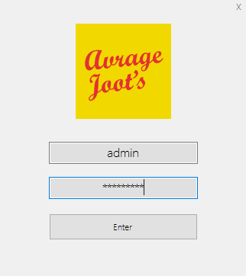

This is how the logo looks on the login screen, I kept it small whilst ensure that it was readable and symmetrical to ensure it looked as clean and professional as possible.
This enables the logo to be both unobtrusive but noticeable enough to catch the eye of users and make the program overall look professional and specifically tailored to average joot’s gym.

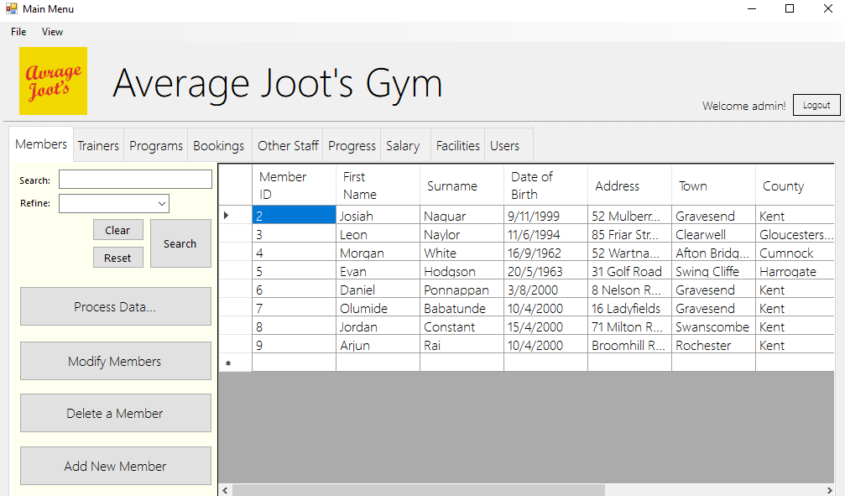
I also took the initiative to add the logo into the main menu. This is to maintain the consistency of the look as well as make the program look more professional.
Furthermore, I ended up adding a label with an “x” on the login page, as one user complained that you couldn’t close the login page without using the taskbar or task manager. I chose to only make this a label, so the login page could still look aesthetically pleasing.

